Q1.Explain String class in java programming?

Ans:

String is a Pre-defined class present in java.lang package

String is Immutable class

If our content are fixed and we won’t perform any modification then we should go for String class

**String class**

1. **String()**
2. **String(String str)**
3. **String(char array)**
4. **String(byte arr[],int start,int number of character)**

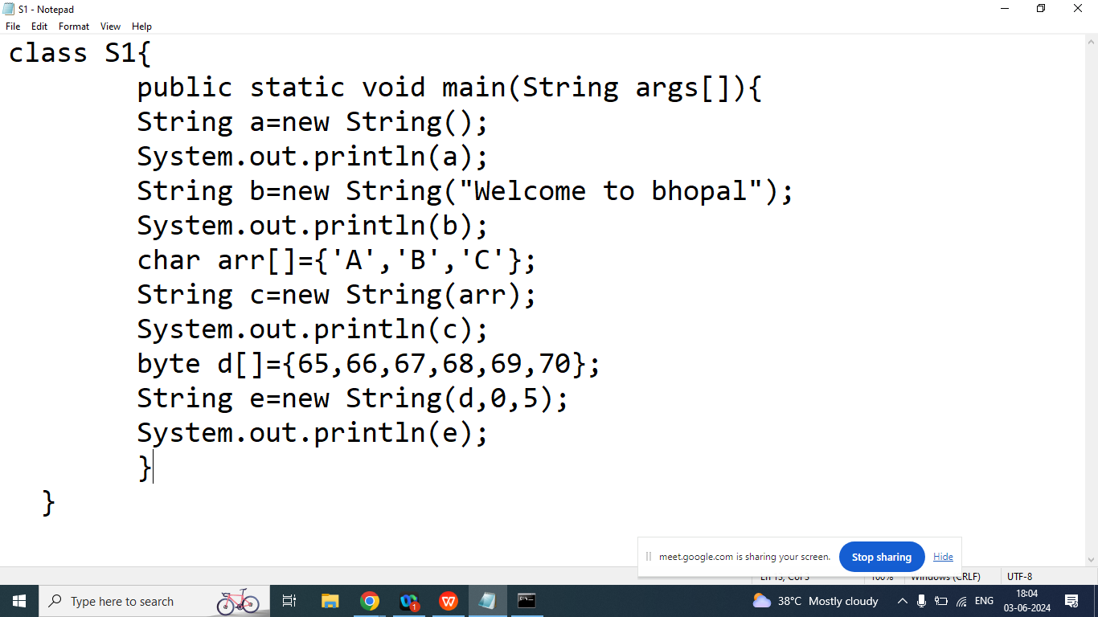

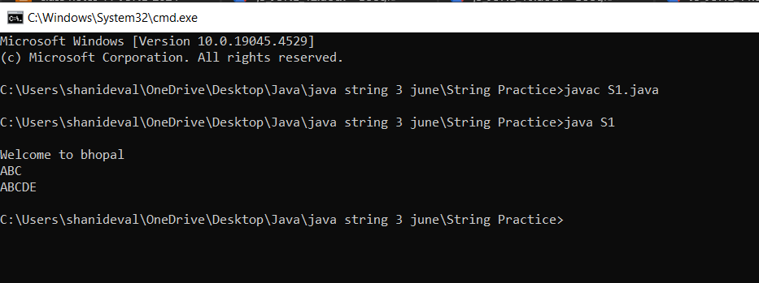

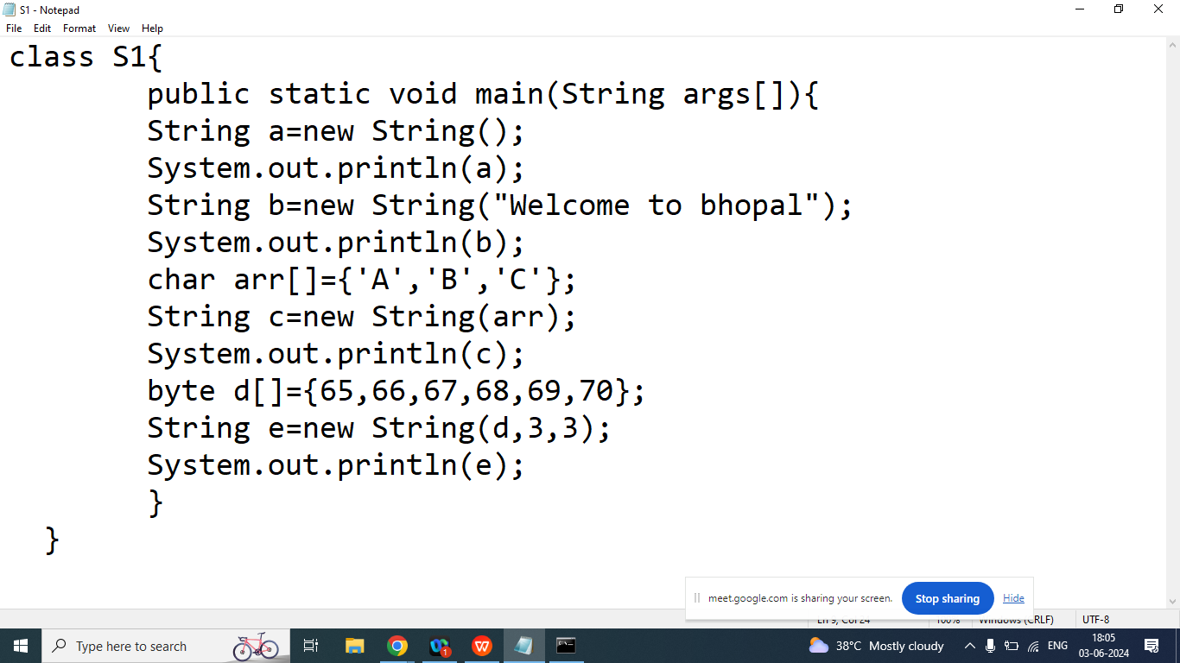

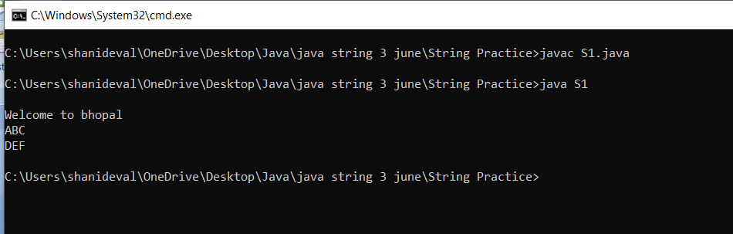

**String class Methods**

1. **charAt()**
2. **compareTo()**
3. **concat()**
4. **contains()**
5. **endsWith()**
6. **equals()**
7. **equalsIgnoreCase()**
8. **isEmpty()**
9. **indexOf()**
10. **lastIndexOf()**
11. **length()**
12. **split()**
13. **startsWith()**
14. **substring()**
15. **toCharArray()**
16. **trim()**
17. **valueOf()**

Q1. Explain String class **charAt()**method?

Ans: Return the character at the specified position

Syntax:

char charAt(int index);

Example:

String str=”Welcome”;

|  |  |  |  |  |  |  |
| --- | --- | --- | --- | --- | --- | --- |
| W | e | l | c | o | m | e |
| 0 | 1 | 2 | 3 | 4 | 5 | 6 |

char x=str.charAt(3);

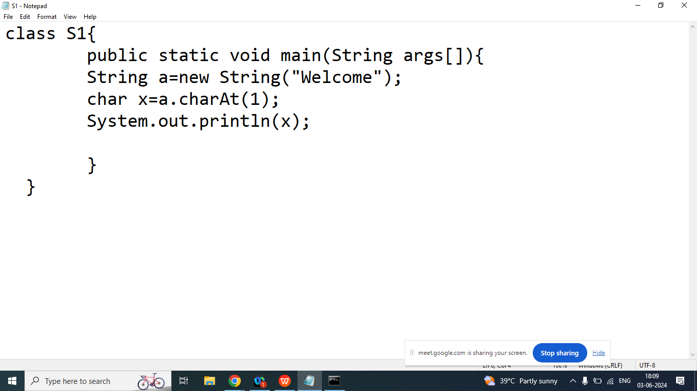

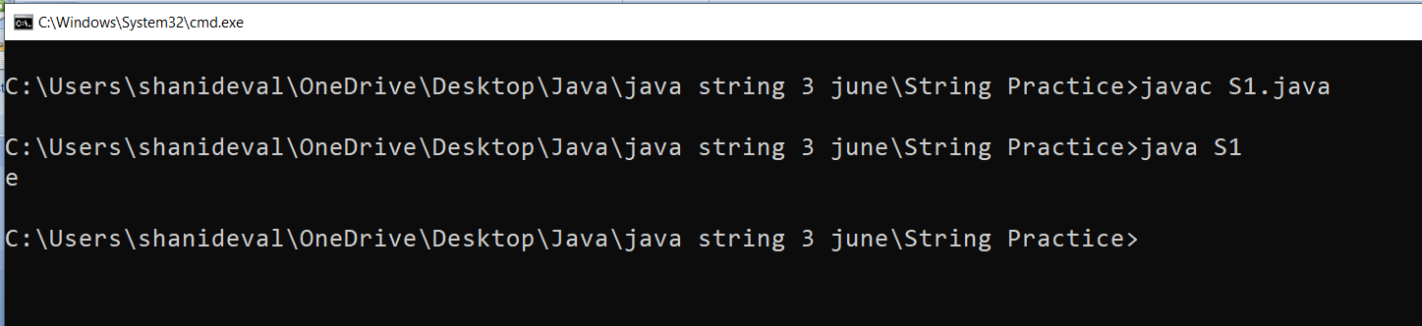

Q2. Explain String class **compareTo()** Method in java programming?

Ans:

It is used to compare two String on the basis of alphabetically order

Syntax:

int compareTo(String)

Example:

String s1=”a”;//97

String s2=”A”;//65

s1.compareTo(s2);: Return Positive value if s1>s2

s1.compareTo(s2);: Return Negative Value value if s1<s2

s1.compareTo(s2): Return 0 if s1 and s2 are equal

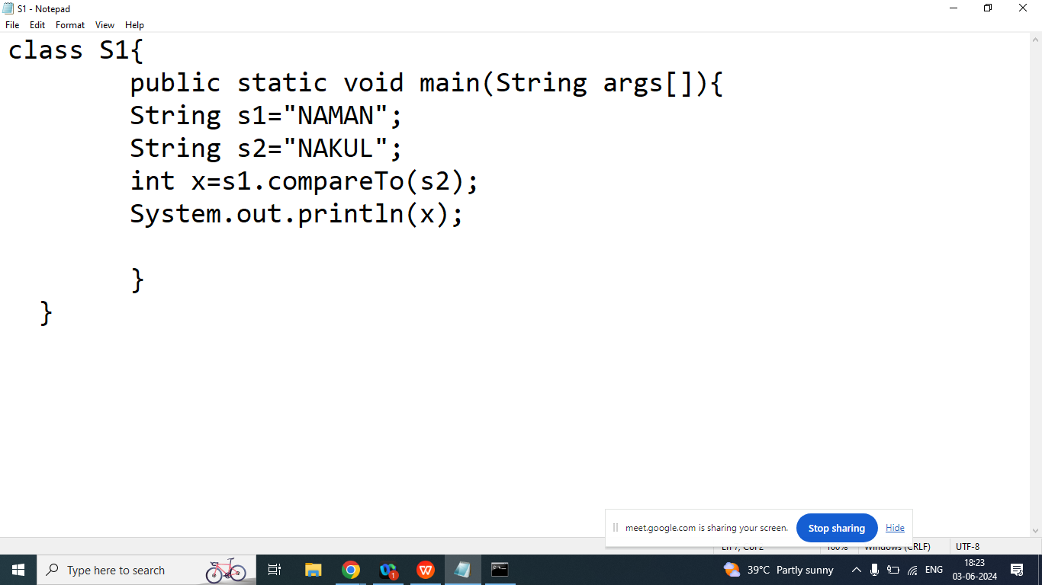

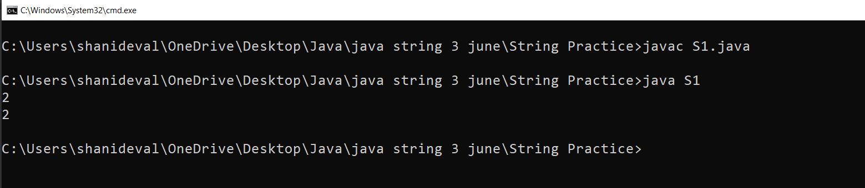

Q3. Explain String class **concat()** Method in java programming?

Ans:

